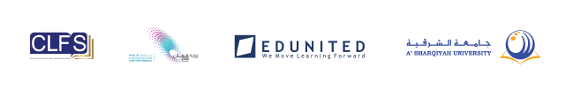
TITLE

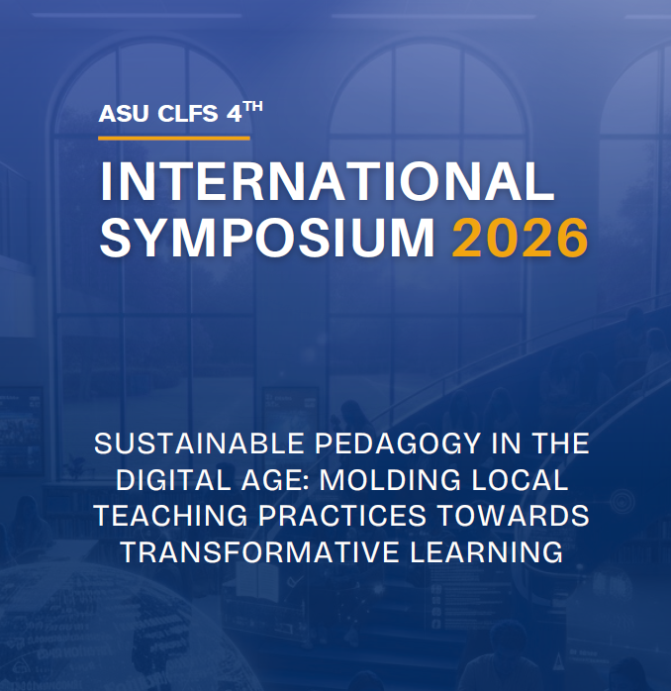

ASU CLFS 4TH INTERNATIONAL SYMPOSIUM 2026

We are pleased to announce the 4th ASU CLFS International Symposium, which will be held at the A' Sharqiyah University on February 9, 2026. Organized by the Centre for Languages and Foundation Studies (CLFS) at A’Sharqiyah University (ASU) in Ibra, this international symposium gathers members of the academic community and industry experts to explore local, innovative, and sustainable teaching approaches in Foundation studies in Oman. It aims to review, update, and capacitate Foundation teachers towards alignment with the OAAAQAE; and fulfilment of Learning, Scientific Research, and National Capabilities as a National Priority of the Oman Vision 2040.

The event hosts interactive presentations and an open forum that highlight current research, digital trends, and best practices that enhance both students’ and teachers’ transformative learning experiences. It specifically targets discourse on student motivation, curriculum development, assessment materials, quality assurance, and teachers’ professional development. Through collaborative discussions, knowledge-sharing, and professional networking, participants will update and develop new teaching practices and even administrative decisions, towards establishing transformative learning as a key contributor to Oman Vision 2040.

KEYNOTE SPEAKER

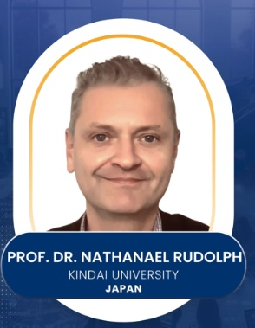 | INSERT SHORT BIO NOTE (SAME IN IG POST)

PLENARY SPEAKERS

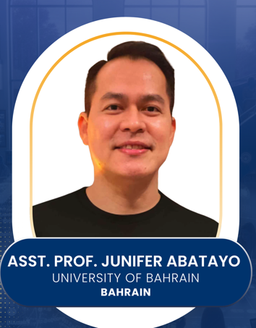 | INSERT SHORT BIO NOTE (SAME IN IG POST)
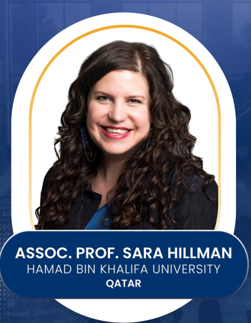 | INSERT SHORT BIO NOTE (SAME IN IG POST)

FEATURE SPEAKER

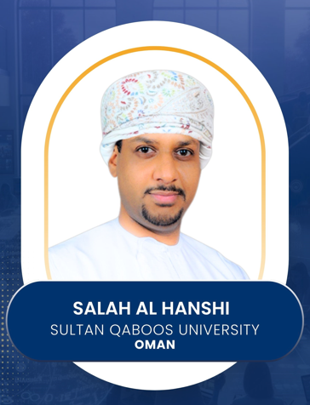 | INSERT SHORT BIO NOTE (SAME IN IG POST)

SYMPOSIUM PROGRAM
FEBRUARY 9, 2026
MAIN AUDITORIUM
A’ SHARQIYAH UNIVERITY

Time | Session
8:00–9:00 AM | Registration, coffee, and breakfast
9:00–9:15 AM | OPENING CEREMONY  National anthem  Opening prayer (reading of the Qur’an)  ASU’s safety protocols
9:15– 9:25 AM | OPENING REMARKS  Dr. Waleed Al Harthy  Director, Center for Language and Foundation Studies (CLFS)
9:25–9:30 AM | INTRODUCTION OF KEYNOTE SPEAKER
9:30–10:15 AM | KEYNOTE SPEAKER  “IDENTITY” AND “(IN)JUSTICE” IN THE DIGITAL AGE: NAVIGATING WAYS OF “SEEING” IN AND BEYOND LANGUAGE EDUCATION  Prof. Rudolph Nathanael  Kindai University
10:15–10:25 AM | PRESENTATION OF CERTIFICATES AND TOKENS TO SPEAKERS  Prof. Yahya Al Wahaibi (ASU VC),  Dr. Ibrahim Sultan Ali Al Harthi (ASU DVC AAR),  and Dr. Waleed Al Harthi (CLFS Director)
10:25–10:30 AM | INTRODUCTION OF PLENARY SPEAKER 1
10:30–11:15 AM | PLENARY SPEAKER 1  AI CARE: AI COMPETENCY FRAMEWORK FOR A SUSTAINABLE EDUCATION 5.0  Asst. Prof. Junifer Abatayo  University of Bahrain
11:15–11:45 AM | OPEN FORUM
11:45 AM–12:00 NN | PHOTO OPPORTUNITY (SPEAKERS, PARTICIPANTS, & ORGANIZERS)
12:00 NN–1:30 PM | LUNCH
1:30–1:35 PM | INTRODUCTION OF PLENARY SPEAKER 2
1:35–2:20 PM | PLENARY SPEAKER 2  INSERT TOPIC (WAITING FOR THE TOPIC)  Assoc. Prof. Sara Hillman  Hamad Bin Khalifa University
2:20–2:25 PM | INTRODUCTION OF FEATURED SPEAKER
2:25–3:10 PM | FEATURED SPEAKER  FROM FRANKINCENSE TO THE GLOBAL: WEAVING OMANI CULTURE INTO ENGLISH LEARNING  Mr. Salah Al Hanshi  Sultan Qaboos University
3:10–3:30 PM | OPEN FORUM
3:30–3:35 PM | HIGHLIGHTS OF ASU CLFS 4TH INTERNATIONAL SYMPOSIUM 2026  Audio Visual Presentation – Showing all the highlights of the event
3:35–3:40 PM | CLOSING REMARKS
3:40–4:00 PM | QR FEEDBACK / PHOTO OPPORTUNITY AT THE CLOCK TOWER

